[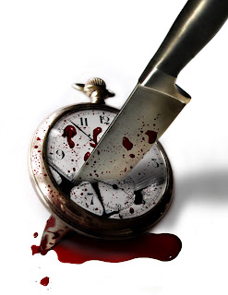](http://1.bp.blogspot.com/-wbppsIlmxfE/Tle8VgJNQiI/AAAAAAAAAi8/8R9LJ9iV-9w/s1600/killing-time.jpg)

-->

Only if some night, I destroyed all the clocks of the world that maintained good time. Only if someday, everyone woke up to the chirruping of the birds or the gleam of the sun than to the annoying alarms.

Clocks have been grossly misunderstood and utterly misused, ever since the idea of keeping time sprouted in someone’s mind. He/She must have been under a seriously funny spell, and then like any other poor joke, this too was shared and spread. ‘*Keeping Time’*? What is that supposed to mean? Time is supposed to flow; it is an entity in the space-time continuum, why would anyone even want to ‘keep it’?

Time is supposed to keep us, it’s a one way street, and any entity trying to be on the reverse route is enroute to oblivion. Yet we tend to run on this conveyor belt in the opposite direction, seldom making progress, only to be prematurely being overcome and overwhelmed by its speed. Like dry sand through hands, time slips away.

Time, it is meant to be aware of something that is passing away, gushing by, like a rivulet. And yet, the gauge that was meant for mere gauging has been bred into an unforgiving master, whipping us, skinning us and we like slaves crawl on bleeding knees, in quagmires of time. The concept of ‘late’, though well established now, should not have been there in the first place. And now, we are too busy trying to avoid the repercussions of being late. Why do we want ourselves to be bound by the idiosyncrasies of time-keeping, routines that grow more mundane, the more rigorously and religiously we follow them?

I too am bound by these like many, only that I’d love to curve out and do something that I’d love to when I’d want to. (Though it is true that most of the time I want to do a thing that I don’t quite know how to do, nothing.) Other times, like days as today when a beautiful person (just because he/she can talk my subject with awe and spellbinding enthusiasm and glee, I’d call the person beautiful. They are like gardeners watering my zeal), I realize that I can never hate the subjects I chose to pursue and would want to give all my time to read them no matter how poorly I had done in past examinations, and yet I merely sigh, *I am too engrossed, I have no time. Need to manage more time.* And then I wonder, how can I do this to something I have come to love, there is time, and always will be, for everything my mind can crave for and desire for.

I believe, *time is meant for historians*. To maintain a chronicled list of events, that is all. For us, time should only be to flow with, in continuum. And as far as keeping time and punctuality are concerned, with the exception of commitments already made, I’d love to forget the watch.

[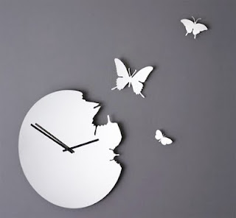](http://3.bp.blogspot.com/-zXvOF0QnmQU/Tle0WsWJp_I/AAAAAAAAAis/4tjlsj8reMg/s1600/butterfly-clock.jpg)